PROJECT DOCUMENTATION
Import Data Using Transform Maps
Spreadsheet-Based Employee Data Import, Validation and Analytics
ServiceNow Micro Project
Date: 30 September 2026

1. Introduction
Project Title: Import Data Using Transform Maps – Spreadsheet-Based Employee Data Import, Validation and Analytics (ServiceNow Micro Project)
Team Members:
S.No | Name | Role
1 | R. MAHAVEERALASKHMI  (Team Lead) | Transform Data & Validate, Enable Coalesce to Avoid Duplicate Records
2 | S. SRIVARSHINI  (Team Member) | Create Import set Table, Report 1
3 | K. SHARMILA JOTHI  (Team Member) | Creation of Tables, Inserting New Data in Excel Format
4 | C.MALLIKA  (TEAM MEMBER) | Creation of Spreadsheet
5 | T. VIJAYADHARSHINI  (Team Member) | Create Transform Map, Adding Reports to Dashboard
.

2. Project Overview

Purpose
This project demonstrates how structured employee data stored in an Excel spreadsheet can be imported into ServiceNow using Import Sets and Transform Maps. The spreadsheet is loaded into a staging Import Set table, and a Transform Map moves the source fields into the matching fields of a custom target table. The imported records are then validated, duplicates are controlled using Coalesce, and reports plus a dashboard present the employee information.
Goals:
- Create a custom Employee Test table with the required employee fields.
- Load spreadsheet data into an Import Set staging table.
- Configure a Transform Map and map source fields to target fields.
- Run the transformation and verify the imported records.
- Use Coalesce to update existing records and avoid duplicate employee entries.
- Create department, location and employee-list reports and consolidate them in a dashboard.

Features
- Spreadsheet import: load an .xlsx file (Employee ID, Employee Name, Email, Department, Location) through Load Data.
- Custom target table: Employee Test (u_employee_test) with five String fields.
- Staging table: Employee Import (u_employee_import) holds raw data before transformation.
- Transform Map: Sample Spreadsheet Import maps all five source columns to target fields.
- Duplicate prevention: Coalesce on Employee ID updates existing records instead of inserting duplicates.
- Analytics: three reports (Pie, Bar, List) combined in the Employee Analytics Dashboards.

3. Architecture
This project is built on the ServiceNow platform rather than the MERN stack, so each MERN layer is replaced by its ServiceNow counterpart, as summarised below.
Layer | MERN equivalent | Used in this project
Frontend | React | Now Platform UI: Application Navigator, forms, lists, Reports and Dashboards
Backend | Node.js + Express.js | Import Set engine and Transform Map (server-side, runs on the ServiceNow instance)
Database | MongoDB | ServiceNow relational database: staging and target tables

Frontend
Users interact through the standard Now Platform interface. The Application Navigator provides access to System Definition → Tables, Load Data, Employee Test and Dashboards. The Employee Test form and list views (configured with Personalize List and Form Layout) show the records, while reports and the Employee Analytics Dashboards provide the visual layer.

Backend
Processing happens through three components:
- Import Set: receives the uploaded spreadsheet rows in the staging table Employee Import.
- Transform Map (Sample Spreadsheet Import): moves data from Employee Import (source) to Employee Test (target) using field maps.
- Coalesce: set on the Employee ID field map so matching IDs update existing records rather than creating duplicates.

Database
Target table: Employee Test (u_employee_test). All fields are of type String.
Field | Type | Mapped from (Employee Import)
Employee ID | String | Employee ID (Coalesce = true)
Employee Name | String | Employee Name
Email | String | Email
Department | String | Department
Location | String | Location

Data flow: Spreadsheet (.xlsx) → Load Data → Employee Import (staging) → Transform Map → Employee Test → Reports → Dashboard.

4. Setup Instructions

Prerequisites
- A ServiceNow instance (for example a Personal Developer Instance) with a user that has administrator access.
- Google Sheets or Microsoft Excel to prepare the source data.
- A modern web browser.
- The employee data file saved as Microsoft Excel (.xlsx) with a header row.

Installation
There is no code to clone or install, and no environment variables are needed. Setup consists of preparing the data and configuring the platform:
- Log in to your ServiceNow instance as an administrator.
- Prepare the spreadsheet with columns Employee ID, Employee Name, Email, Department and Location, then save it as .xlsx (Phase 1).
- Create the custom table Employee Test and its five String fields (Phase 2).
- Create the import table Employee Import using Load Data (Phase 3).
- Create and configure the Transform Map Sample Spreadsheet Import (Phase 4).

5. Folder Structure
ServiceNow projects are configured inside the platform, so there are no client/server code folders. The table below gives the equivalent organisation of the project artifacts.
Area | Location / Navigation | Contents
Client (UI) | All → Employee Test; Dashboards; Reports | List and form views, 3 reports, Employee Analytics Dashboards
Server (processing) | All → System Definition → Tables; Load Data; Transform Maps | u_employee_test, u_employee_import, Sample Spreadsheet Import with 5 field maps
Source data | Local file (.xlsx) | Employee spreadsheet with header row

6. Running the Application
No npm commands are required. The equivalent of starting the application is loading the data and running the transform:
Step | Action
Load data | Application Navigator → Load Data → select Employee Import → Select File (.xlsx) → Submit
Run transform | Click Transform in the Transform Map (first import) or Run Transform → select the Import Set and Sample Spreadsheet Import → Transform
View output | All → Employee Test (list); Dashboards → Employee Analytics Dashboards

7. API Documentation
This project does not expose a custom API; all operations are done through the ServiceNow user interface. For reference, the target and staging tables can also be reached through ServiceNow’s standard REST APIs. Field names shown are the typical auto-generated ones, so confirm them in your instance before use.
Method | Endpoint | Purpose
GET | /api/now/table/u_employee_test | List Employee Test records (supports sysparm_limit, sysparm_query)
GET | /api/now/table/u_employee_test/{sys_id} | Retrieve one employee record
POST | /api/now/table/u_employee_test | Create an employee record
POST | /api/now/import/u_employee_import | Insert a row into the staging table and trigger the transform

Example response (GET, one record):
{
"result": [{
"sys_id": "…",
"u_employee_id": "101",
"u_employee_name": "Sample Name",
"u_email": "sample@example.com",
"u_department": "IT",
"u_location": "Chennai"
}]
}

8. Authentication
- Authentication: users sign in to the ServiceNow instance; the browser session is maintained by the platform. REST calls would use basic authentication or OAuth tokens.
- Authorization: role-based. Creating tables, transform maps and importing data requires administrator access.
- Access control: if dashboard creation is blocked, an authorised administrator must adjust the ACL for the PA dashboards table as per the project guide. Only authorised administrators should change access controls.

9. User Interface
The screenshots below follow the project phases.

Phase 1 – Spreadsheet Preparation
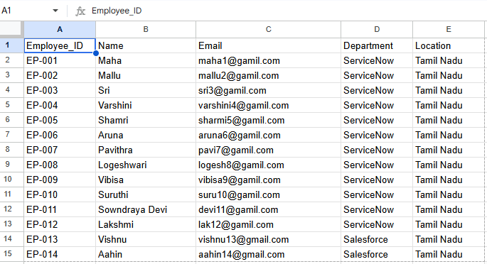
Figure 1: Sample employee spreadsheet

Phase 2 – Custom Target Table
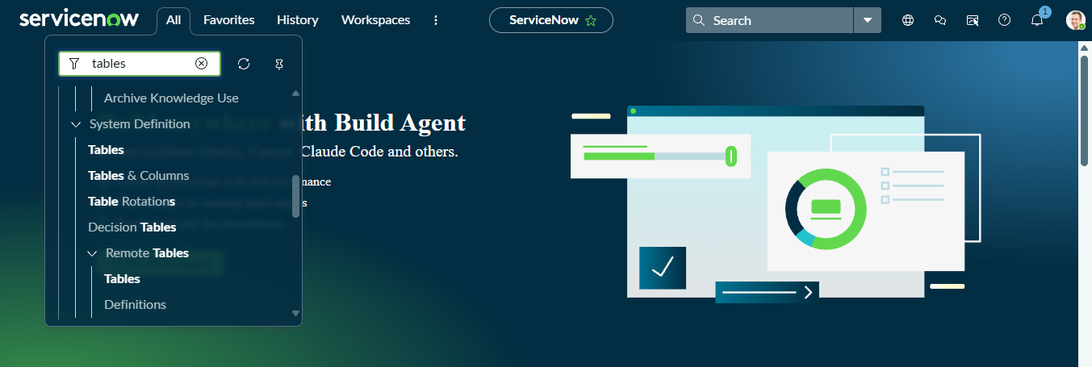
Figure 2: Navigator menu (System Definition → Tables)
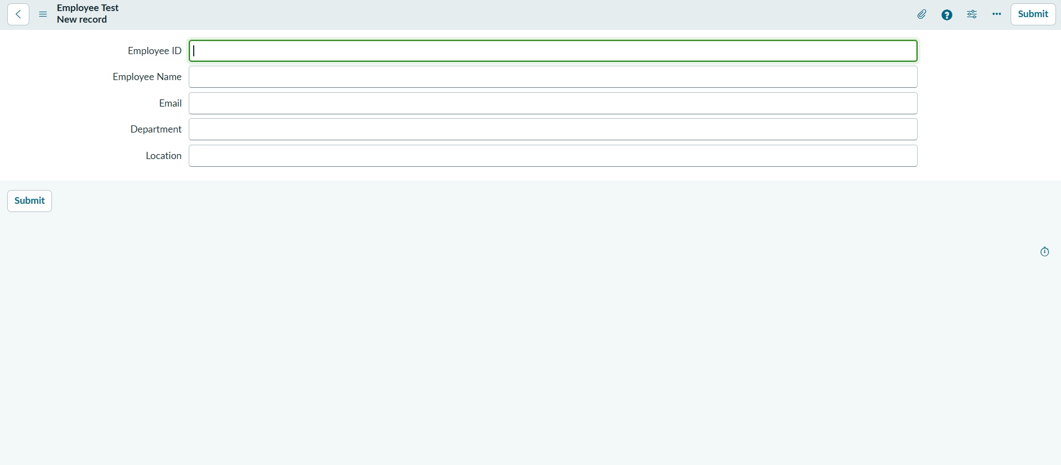
Figure 3: Employee Test table with its fields

Phase 3 – Import Set Table
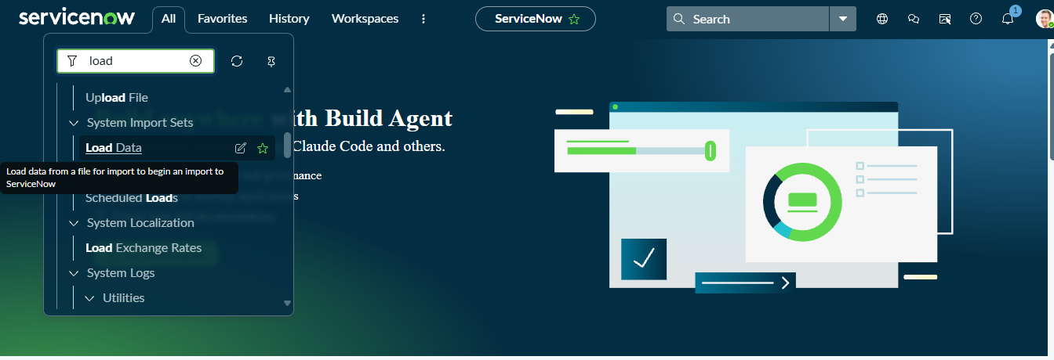
Figure 4: Load Data in the Application Navigator
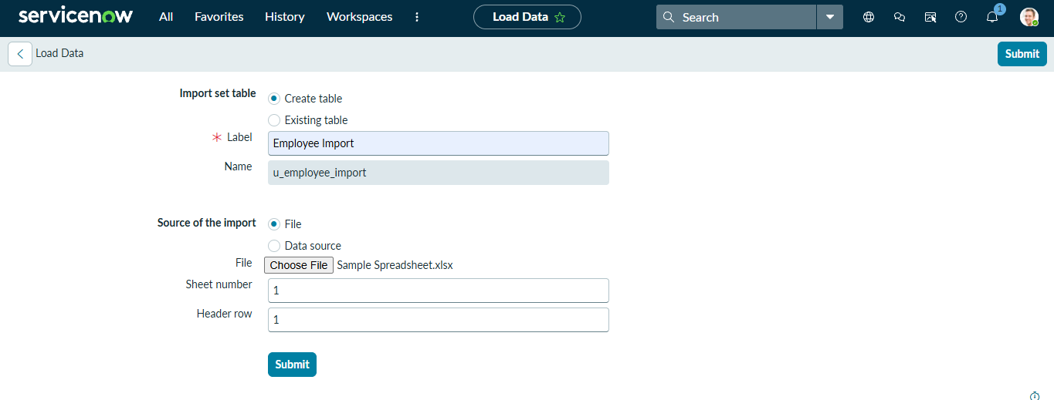
Figure 5: Creating the Employee Import table

Phase 4 – Transform Map Configuration
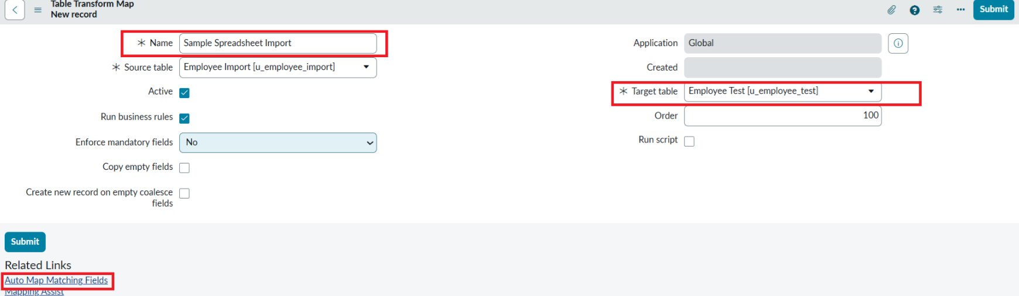
Figure 6: Transform Map – source and target tables
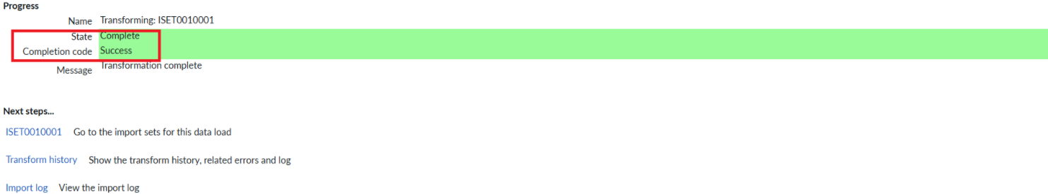
Figure 7: Transform Map saved and transform run

Phase 5 – Transform and Validate
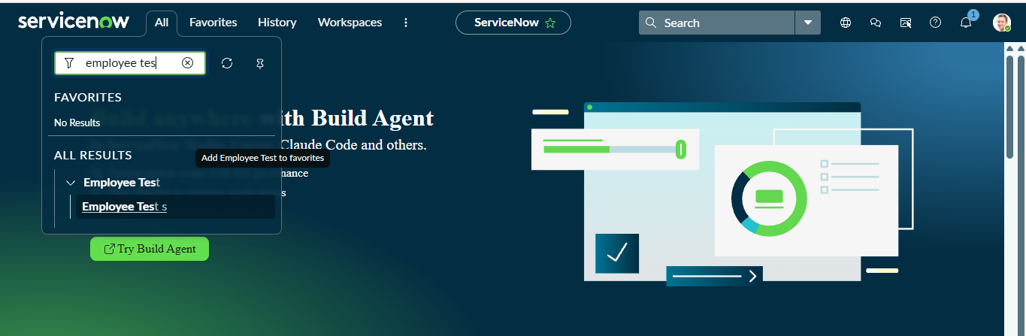
Figure 8: Opening the Employee Test table from the navigator
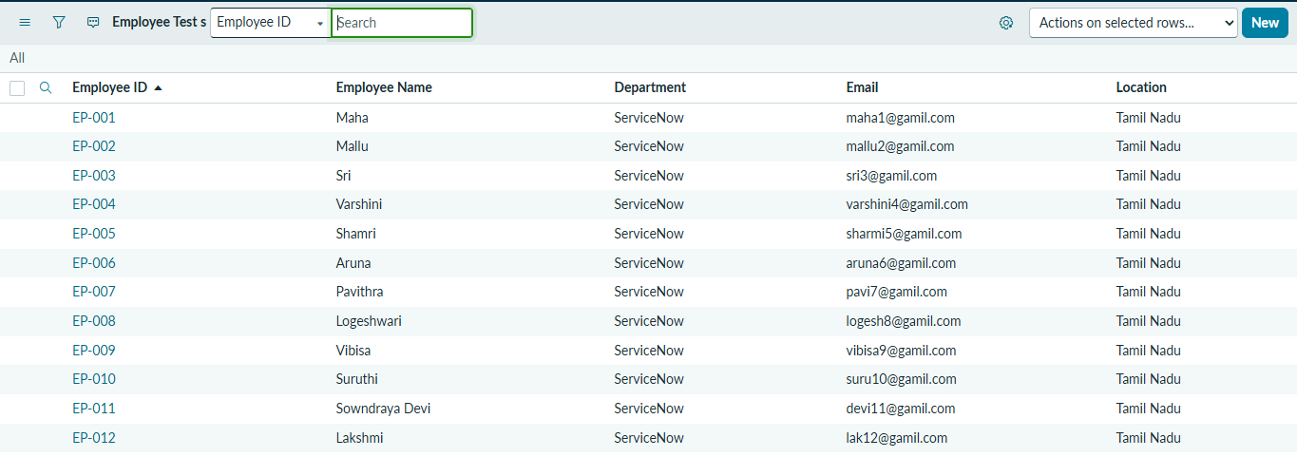
Figure 9: Imported records in Employee Test

Phase 6 – Coalesce
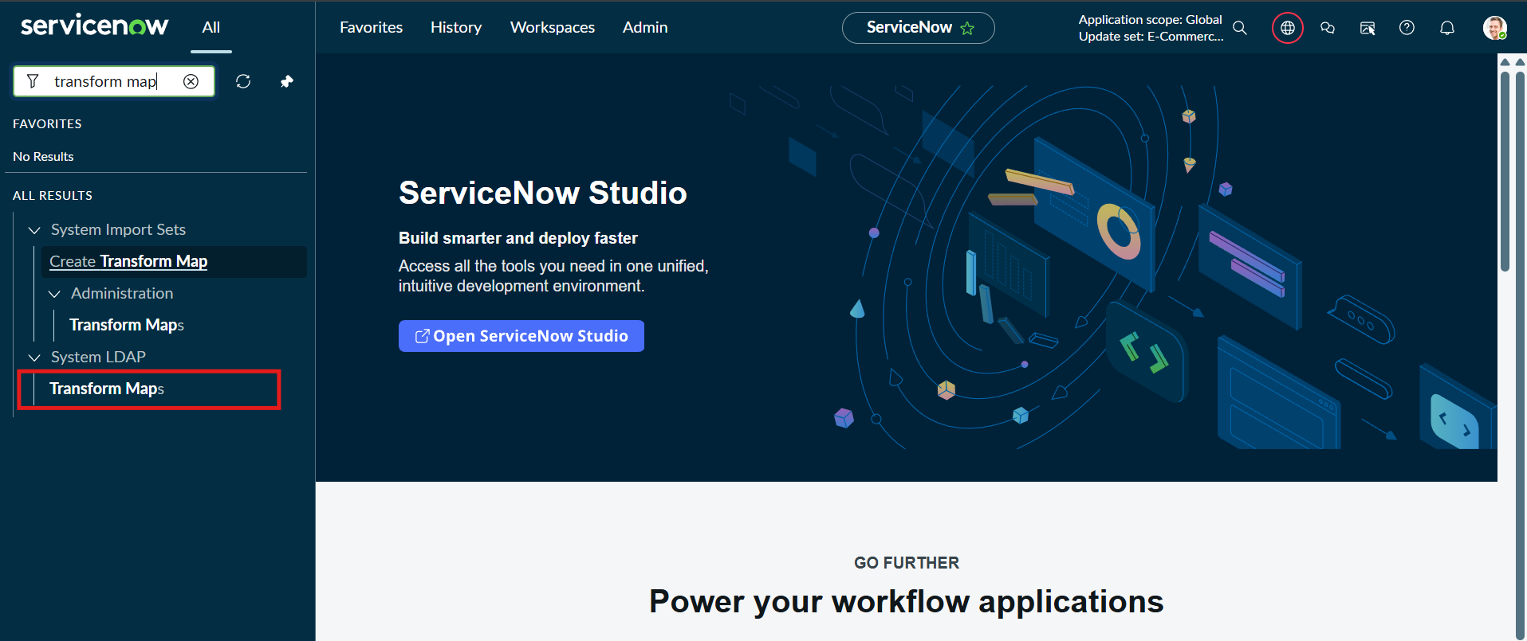
Figure 10: Opening Transform Maps from the navigator
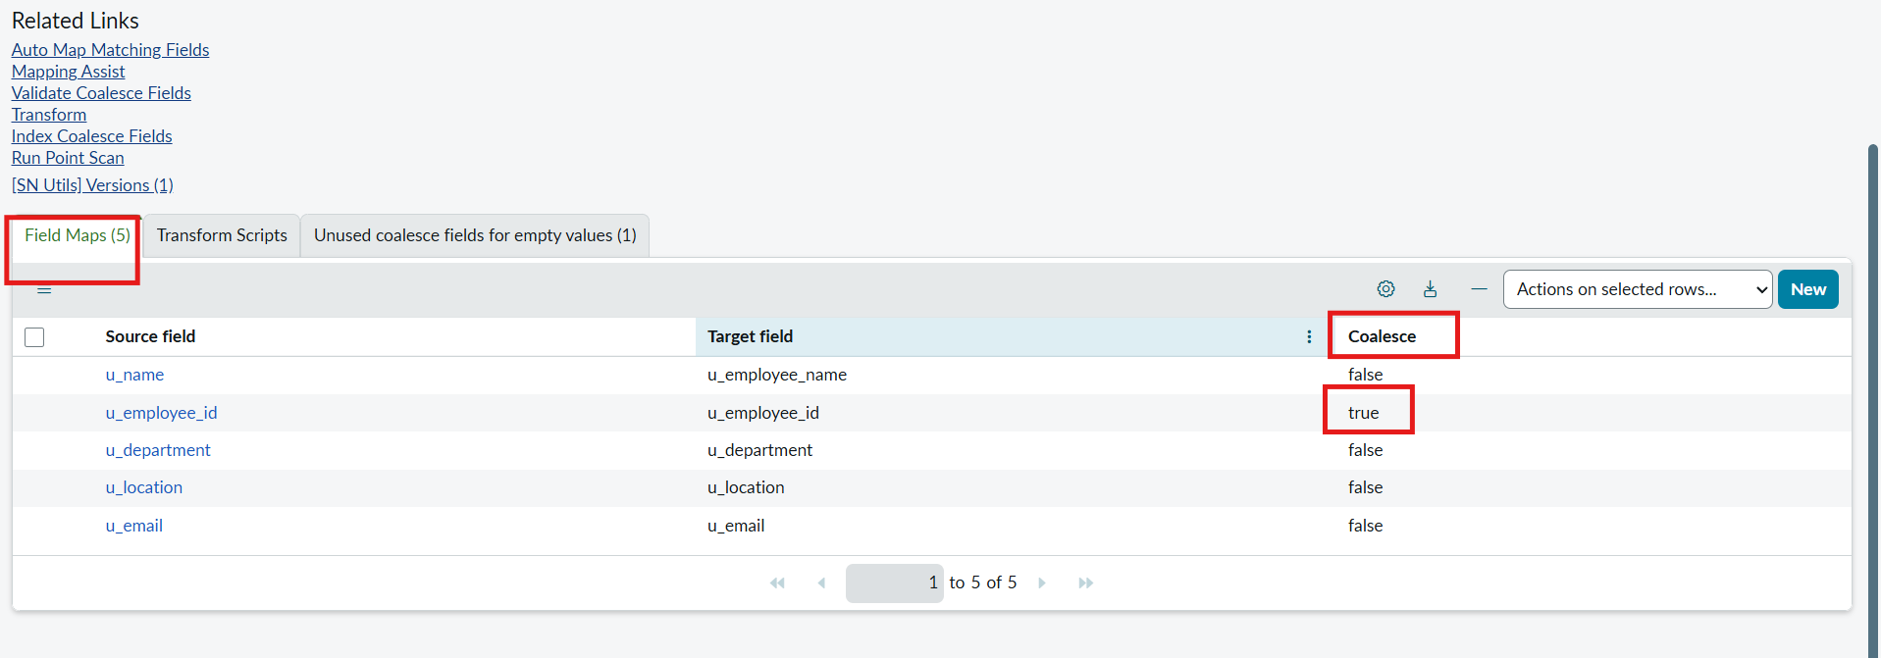
Figure 11: Field Maps related list – Coalesce on Employee ID

Phase 7 – Updated and New Data Import
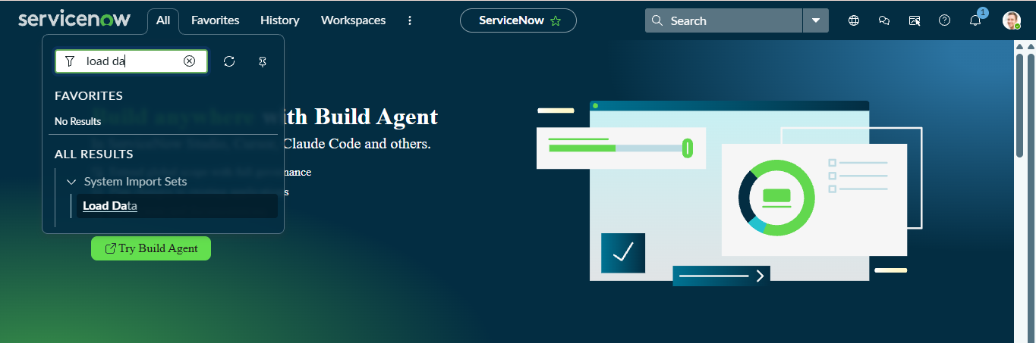
Figure 12: Load Data for the updated spreadsheet
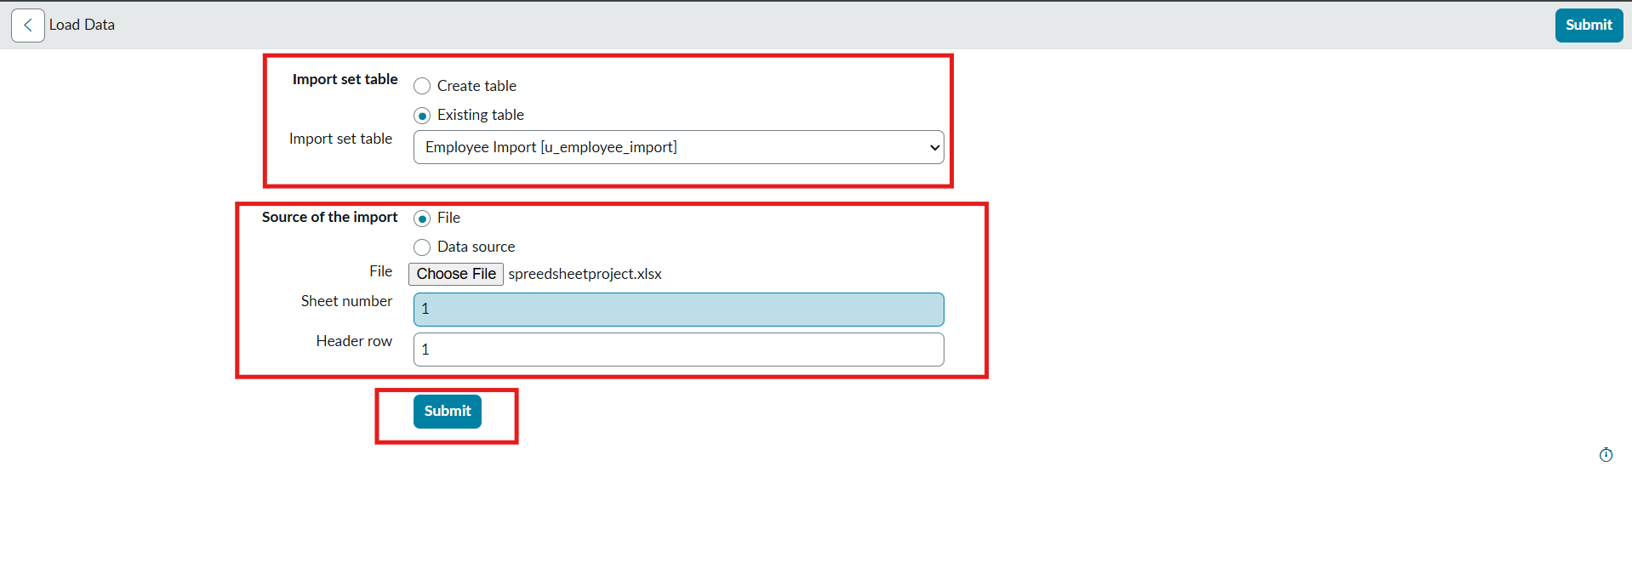
Figure 13: Uploading the file to the existing Employee Import table
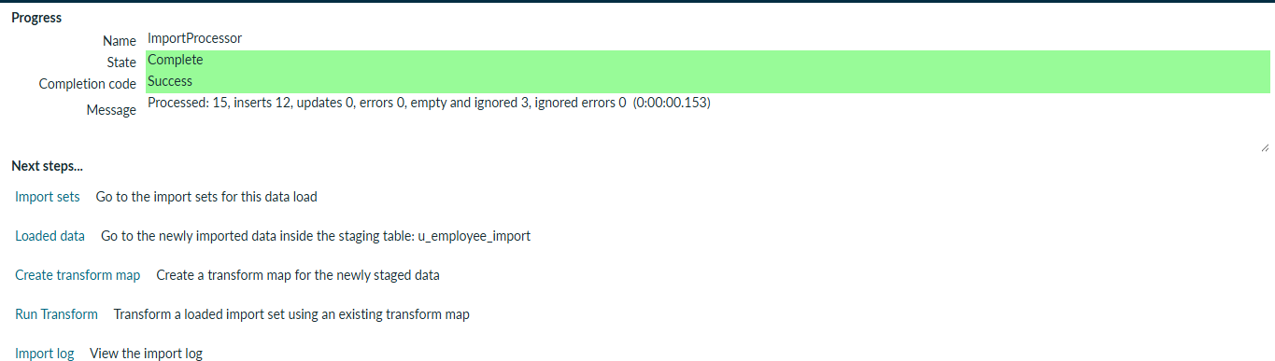
Figure 14: Import set completed
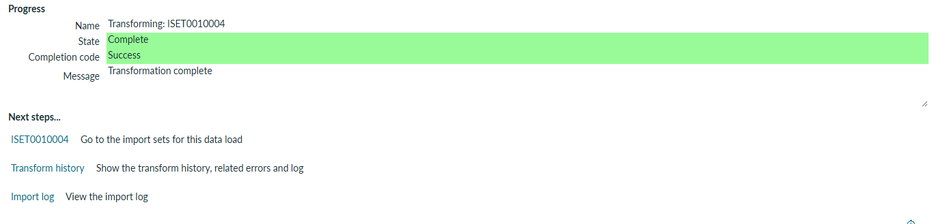
Figure 15: Transform run progress
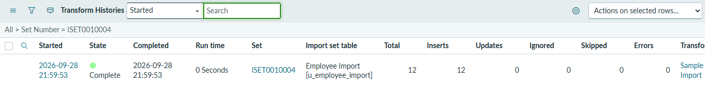
Figure 16: Transform history showing inserted and updated counts

10. Testing
Testing was manual and functional, performed inside ServiceNow by comparing platform data with the source spreadsheet. No automated test tools were used.
ID | Test | Expected result | Phase
T1 | Import spreadsheet and run transform | All rows appear in Employee Test with matching values | 5
T2 | Compare list with source file | Row count and field values match | 5
T3 | Re-import with Coalesce on Employee ID (2 existing, 2 new IDs) | 2 records updated, 2 inserted | 7
T4 | Re-import the same unchanged file | No additional inserts or updates | 7
T5 | Open the dashboard | All three report widgets displayed | 9

Note: exact status labels can vary by ServiceNow version and configuration.

11. Screenshots or Demo
Reports and dashboard output:
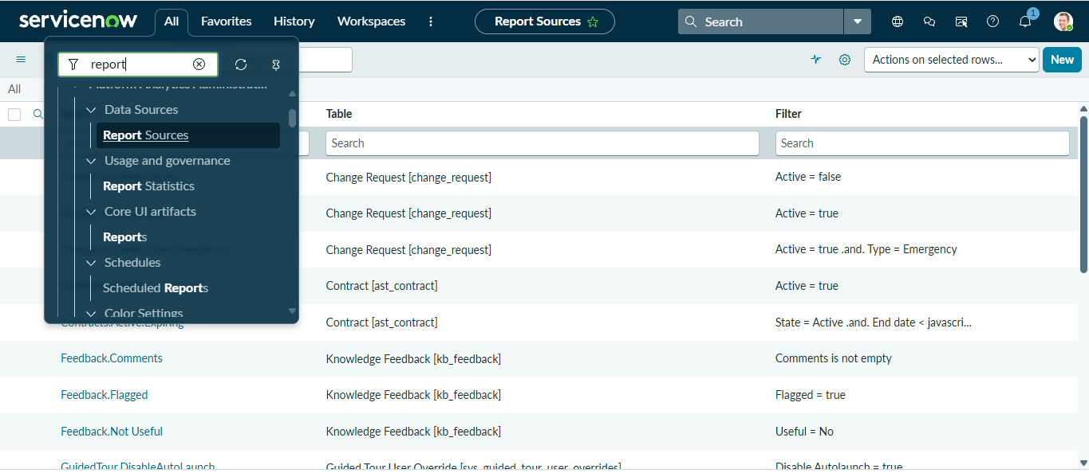
Figure 17: Opening Reports from the navigator
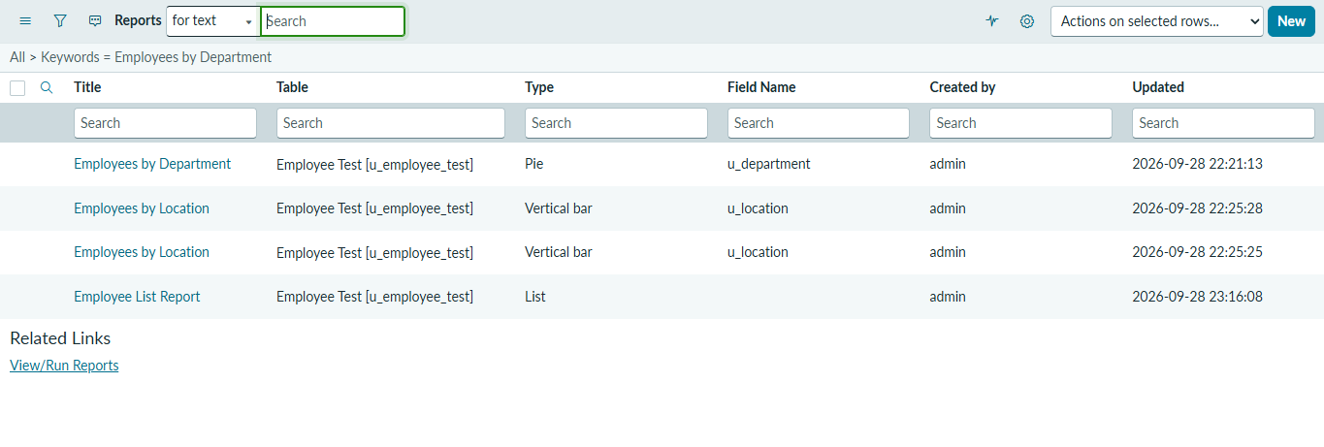
Figure 18: Saved reports (Employees by Department, Employees by Location, Employee List Report)
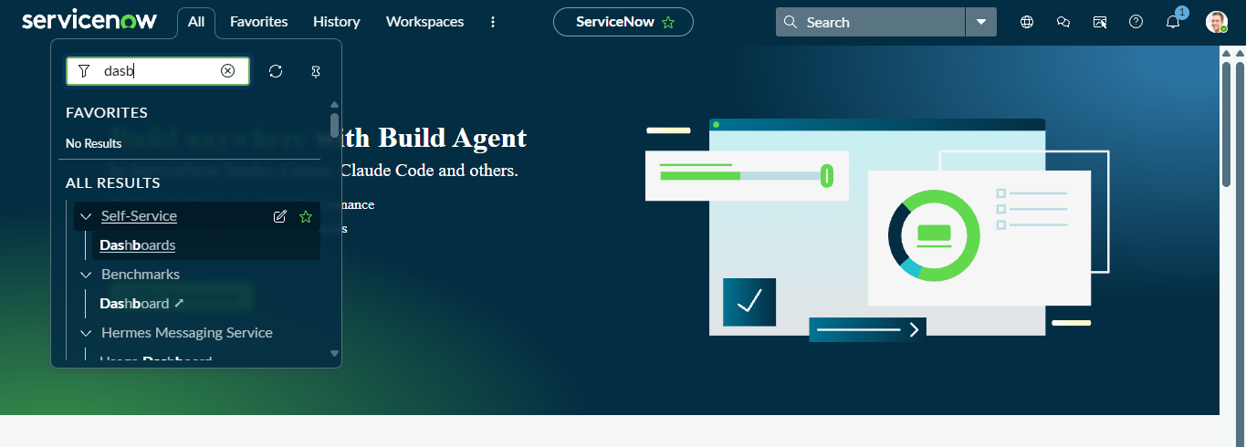
Figure 19: Opening Dashboards from the navigator
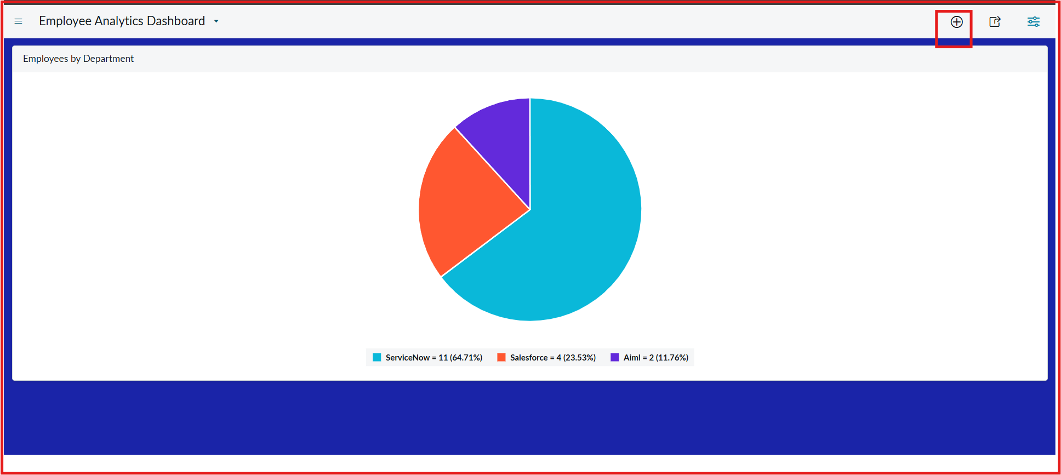
Figure 20: Employee Analytics Dashboards with report widget
Demo link: Watch project demo video

12. Known Issues
- Dashboard creation may be blocked by access controls; an authorised administrator must configure the ACL for the PA dashboards table.
- Import status labels and some menu options (for example Auto Map Matching Fields) vary by ServiceNow version and configuration.
- All fields are String type, so Employee ID and Email are not format-validated during import.
- Coalesce must be set to true before re-importing; otherwise duplicate records are created.
- Import is manual: a file must be uploaded and the transform run each time.

13. Future Enhancements
- Add a transform script or Field Map validation for email format and mandatory fields.
- Change Department and Location to Choice or Reference fields for cleaner reports.
- Use a Data Source with a scheduled import to automate loading.
- Import data through the REST Import Set API instead of file upload.
- Add error notifications and an import log report.
- Add role-based access so HR users can view but not modify records.

Conclusion
The project provides practical experience in spreadsheet data migration, staging tables, field mapping, transformation execution, duplicate prevention and reporting in ServiceNow. Import Sets, Transform Maps, Coalesce, reports and dashboards together form a repeatable workflow for importing and reviewing employee data.

